ACS-2814-052: Applications Of Database Systems
Lab 2

Daljeet Singh, 3169763

Part A: Filtering in Access
Place screenshots of the key steps in the table below

Question | Screenshot (paste below, adjacent to each question)
6a. How many days in the year was there significant (10mm or more) of precipitation? | 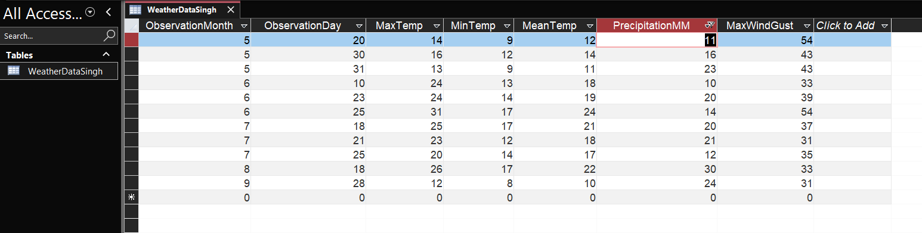
6b. How many days in which there was significant (more than 10mm) precipitation was there also windy conditions (40 km/hr or higher gusts)? | 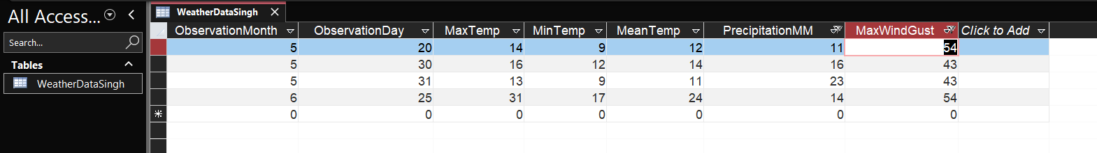
6c. Produce a list of the dates in where it was -20 or colder in December. Sort the dates by coldest to warmest. | 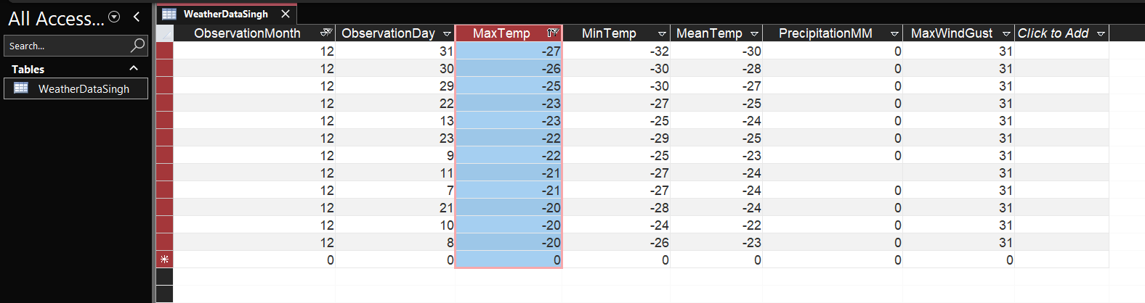
6d. On which days did the weather station fail to record an average temperature during the winter months (Nov, Dec, Jan, Feb, March)? | 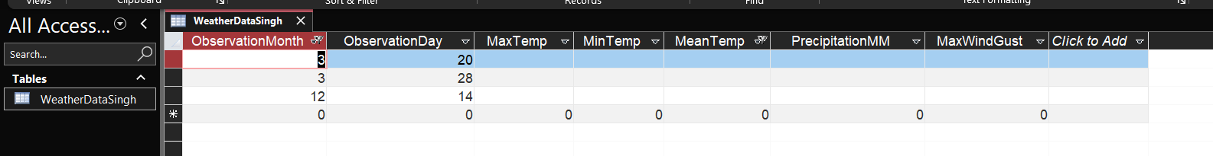

Part B

8.  Take a screenshot of your relationship window after completing all the relationships | 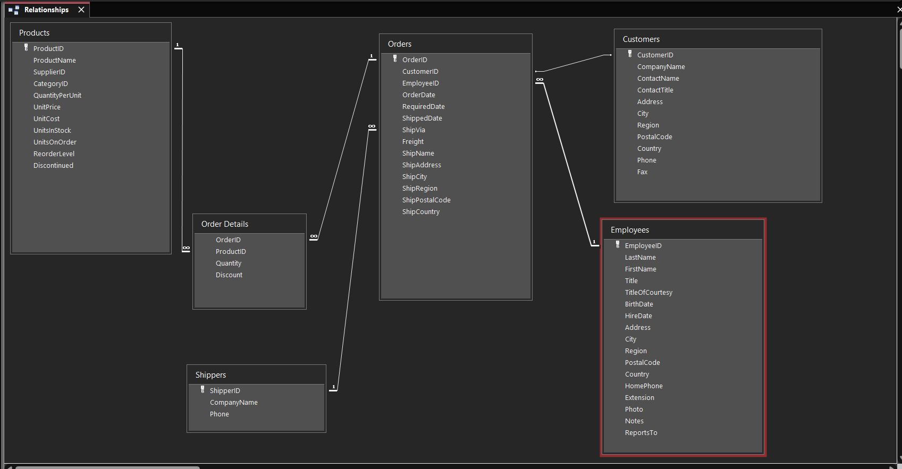
9.  Take a screenshot of your relationship window showing the added column. | 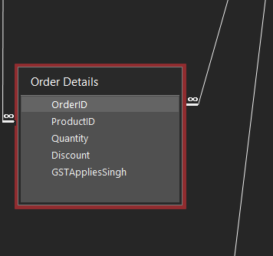
10.  Take a screenshot of your relationship window showing the added column and change in relationship between shippers and orders. | 